**The First Congregational Church of Bethel, 46 Main Street Presents !**

Your

Choice

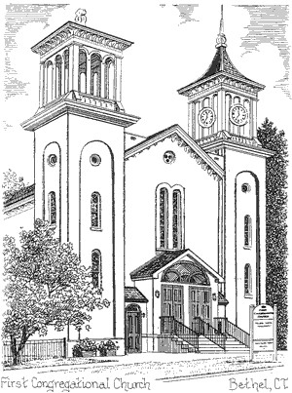

**A Curbside pickup or Dine IN**

**Pot Roast Dinner**

**Saturday December 7th, 2024**

**Curbside pickup time:(you choose when) 4:00 PM - 5:00 PM Curbside Pickup location: In front of First Congregational Church. Meals packed and delivered to your car.**

**-- Or --**

**Dine In time: 5:30 - 7:00 PM**

**Dine In location : Church fellowship Hall, lower level.**

**The meal features:**

**Pot Roast and Gravy - Mashed Potatoes - Peas**

**Red Cabbage - Salad - Homemade bread - Dessert**

**Ticket Price: $25.00 All meals will be by advanced orders.**

**Present the right side of the ticket (include your name) at pickup or when you Dine with us.**

**Return the completed left side of the ticket with your; name, payment, requested # of tickets and pickup time requested (if picking up).**

**Please return advanced ticket purchases by Thursday**

**December 5th, 2024**

**Request for additional tickets for friends/neighbors**

**Church Office: 203-743-1877**

**call Lillian (203) 748-6112 or text David (203)-733-9072 or e-mail request for tickets to doskandy@comcast.net**

**Make checks payable to The First Congregational Church of Bethel.**

**Thank you for your support.**